800 new homes? Not in this location, location, location, says Phil Spencer
Ben Ellery
November 9 2019, 12:01am, The Times
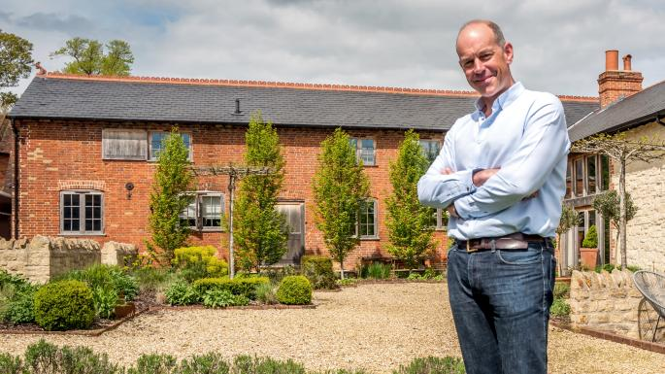
The presenter Phil Spencer lives near a proposed development site in Hampshire
ANDREW HASSON FOR THE SUNDAY TIMES
He is the celebrity property developer who has forged a television career helping people find their perfect home.
But Phil Spencer is leading local objections to plans for 800 properties on a site that would also provide a school, shops and 500 jobs.
The site in Bentley, Hampshire, called Northbrook Park, is near where the Location, Location, Location presenter lives in a £3.5 million pile in Froyle, complete with ten acres, a tennis court, gym, cinema and games room.
The proposal, which will be made up of 40 per cent “affordable homes”, has also attracted the objections of the Alan Titchmarsh, 70, who lives near by.
Northbrook Park is one of ten sites suggested to East Hampshire district council to meet government targets of building 10,456 homes by 2036. Current projects will provide 7,078, meaning that an extra 3,378 house need to be built over the next 16 years.
The Northbrook Park plans include proposals to improve bus services, build wildlife ponds, an outdoor gym and children’s play areas.
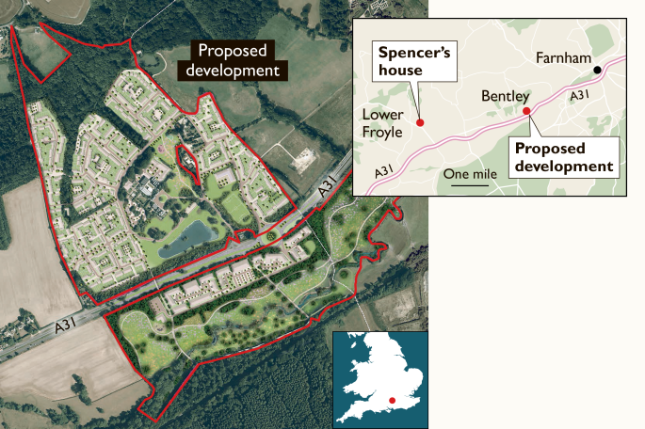
In a background paper prepared by council planning officers, the site passed a two-stage assessment looking at whether it was sustainable.
However, campaigners claim that the development will cause gridlock on roads and blight the landscape.
In his objection Spencer, 49, a patron of St Mungo’s, a London homelessness charity, said he was “in principle supportive of housing development, especially affordable homes for the younger generation” but “this is the wrong development in the wrong place”.
“As proposed, it is not in any way sustainable and I do not believe it is either suitable or deliverable,” he added. “I believe there are far better sites in East Hants to build 800-plus houses than at Northbrook.”
Mr Titchmarsh said: “As a long-term resident of Holybourne, the countryside is of great importance to me. I support protecting the rolling fields, beautiful landscape and ancient woodland of the Northern Wey Valley, which is on the edge of the South Downs National Park.”
There are 430 houses in Bentley, which featured in a reality TV show called The Village. It ran from 1993 until 2001 and showed the everyday lives of residents including Andrew Thomson, a retired submarine captain, and “Dave”, a plumber by day and Elvis impersonator at night.
Bruce Powell, the founder of the Bentley Action Group, which is campaigning against the project, said: “We’re not against building in this part of the world but we are against massive developments in beautiful parts of the countryside.
“It’s a shame because by selecting ten proposals the council has pitted communities against each other. They chose Northbrook because it is on the border of Surrey and they think it will be their problem to deal with. It’s a battle we continue to fight and we are determined to fight it.”
The landowner Nicolas Roach could not be contacted for comment.

